EX NO: 8b | SIMULATION AND ANALYSIS OF QPSK MODULATION USING CONSTELLATION DIAGRAMS IN MATLAB
DATE:

Objective
i) To generate QPSK symbols from a binary data sequence using quadrature phase-shift keying principles.
ii) To plot and analyze the QPSK signal constellation in the In-Phase (I) and Quadrature (Q) plane.
iii) To investigate the effect of noise on constellation points and evaluate the resulting degradation in symbol detection performance.

Matlab code

clc;
clear;
close all;

%% Objective 1: Generate QPSK Symbols
N = 1000; % Number of bits
data = randi([0 1], N, 1); % Random binary sequence

% Ensure even number of bits
if mod(N,2)~=0
data = [data; 0];
N = N + 1;
end

% Group bits into pairs
bit_pairs = reshape(data,2,[])';

% QPSK Mapping

qpsk_symbols = zeros(size(bit_pairs,1),1);
for k = 1:size(bit_pairs,1)
if isequal(bit_pairs(k,:),[0 0])
qpsk_symbols(k) = (1+1j)/sqrt(2);
elseif isequal(bit_pairs(k,:),[0 1])
qpsk_symbols(k) = (-1+1j)/sqrt(2);

elseif isequal(bit_pairs(k,:),[1 1])
qpsk_symbols(k) = (-1-1j)/sqrt(2);
elseif isequal(bit_pairs(k,:),[1 0])
qpsk_symbols(k) = (1-1j)/sqrt(2);
end
end

%% Objective 2: Plot QPSK Constellation

scatter(real(qpsk_symbols),imag(qpsk_symbols), 30);
xlim([-1 1])
ylim([-1 1])
hold on;

xline(0,'k','LineWidth',1.5);
yline(0,'k','LineWidth',1.5);

grid on;
axis equal;

xlabel('In-Phase (I)');
ylabel('Quadrature (Q)');
title('Ideal QPSK Constellation');

%% Objective 3: Add Noise and Evaluate Performance
SNR = 5;

rx_signal = awgn(qpsk_symbols,SNR,'measured');

figure;
scatter(real(rx_signal),imag(rx_signal), 15);
hold on;

xline(0,'k','LineWidth',1.5);
yline(0,'k','LineWidth',1.5);

grid on;
axis equal;
xlabel('In-Phase (I)');
ylabel('Quadrature (Q)');
title(['Noisy QPSK Constellation (SNR = ',num2str(SNR),' dB)']);

%% Symbol Detection
detected_bits = zeros(length(rx_signal)*2,1);
for k = 1:length(rx_signal)
I = real(rx_signal(k));
Q = imag(rx_signal(k));
if I>0 && Q>0
bits = [0 0];
elseif I<0 && Q>0
bits = [0 1];
elseif I<0 && Q<0
bits = [1 1];
else
bits = [1 0];
end
detected_bits(2*k-1:2*k) = bits;
end

%% BER Calculation
num_errors = sum(data ~= detected_bits);
BER = num_errors/N;
fprintf('Number of Transmitted Bits : %d\n',N);
fprintf('Number of Bit Errors : %d\n',num_errors);
fprintf('Bit Error Rate (BER) : %f\n',BER);

Objective (i): Generate QPSK Symbols from a Binary Data Sequence Using Quadrature Phase-Shift Keying Principles

Procedure:
- Initialize the MATLAB environment and define the number of bits.
- Generate a random binary sequence consisting of 0s and 1s.
- Group the binary sequence into pairs of bits.
- Apply QPSK modulation by mapping each bit pair to a unique constellation point.
- Generate the corresponding complex QPSK symbols.
- Verify that four distinct symbol values are obtained.
- Store the generated symbols for constellation analysis.

OUTPUT:

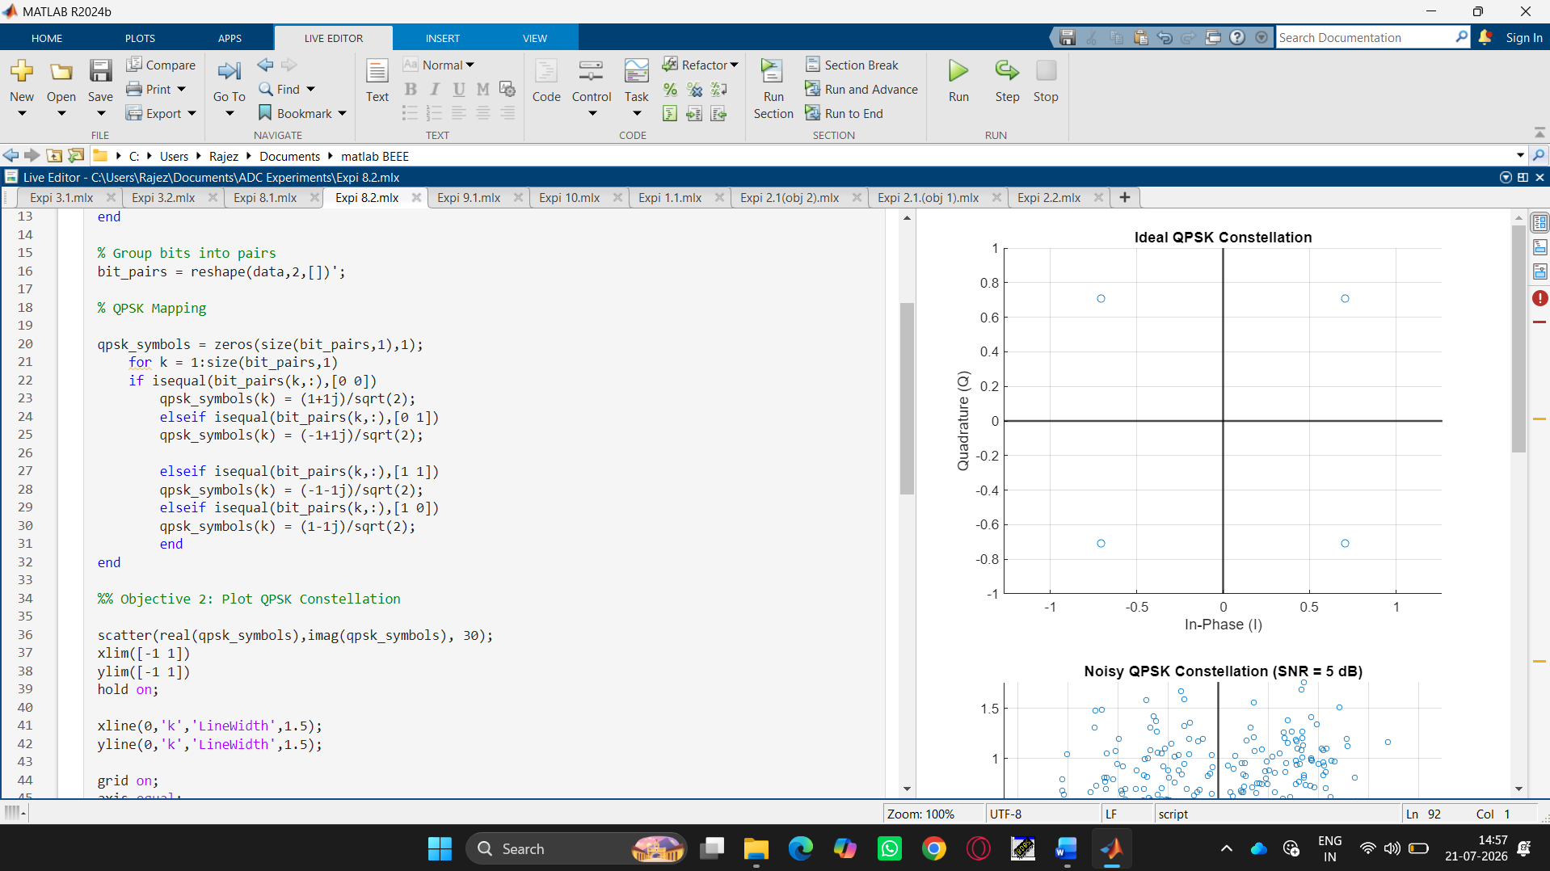

Result
The QPSK constellation was successfully plotted in the In-Phase (I) and Quadrature (Q) plane, showing four distinct symbol points corresponding to the bit pairs 00, 01, 11, and 10.

